App8个入口录入说明

位置
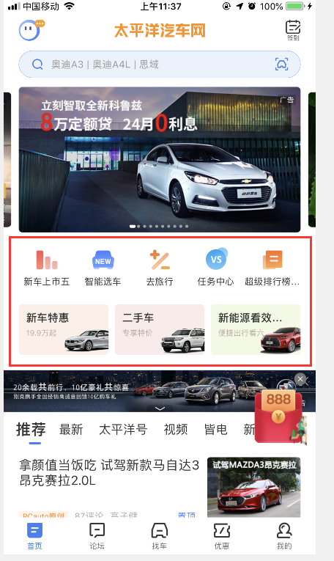

录入后台
地址：http://madmin.pconline.com.cn/login.jsp
文件：home_function_entry
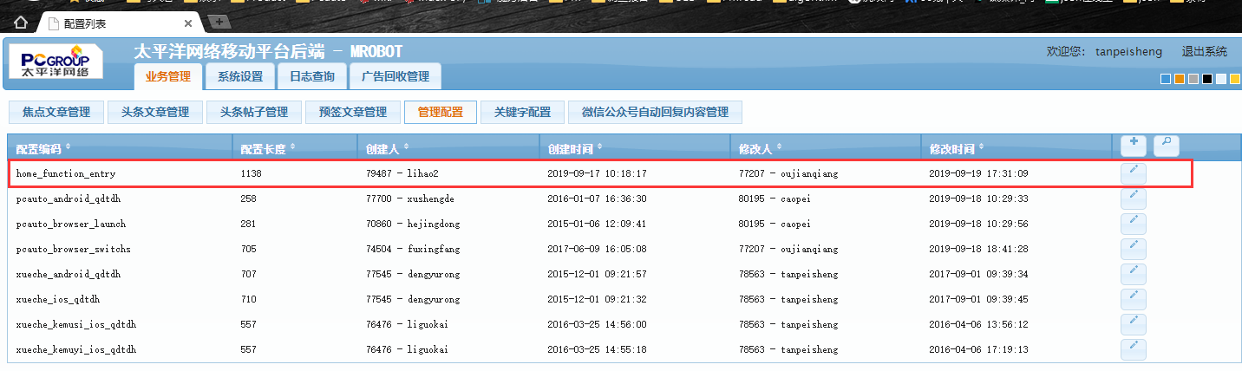

8个入口都录入例子：
{
"functionEntries": {
"firstEntryList":[
{
"icon": "http://www1.pcauto.com.cn/app/20190905/xiaoliang.png",
"title": "新车上市五",
"url": "pcautobrowser://new-cars-info-list/"
},
{
"icon": "http://www1.pcauto.com.cn/app/20190905/xinche.png",
"title": "智能选车",
"url": "pcautobrowser://ai_findCar_preference/"
},
{
"icon": "http://www1.pcauto.com.cn/app/20190905/jisuan.png",
"title": "去旅行",
"url": "pcautobrowser://bbs-home-new/?tabIndex=1"
},
{
"icon": "http://www1.pcauto.com.cn/app/20190905/duibi.png",
"title": "任务中心",
"url": "pcautobrowser://bonuspoint-task/"
},
{
"icon": "http://www1.pcauto.com.cn/app/20190905/xuanche.png",
"title": "超级排行榜首页",
"url": "pcautobrowser://super_rank_list_detail/?keyword=销量好的车系"
}
],
"secondEntryList":[
{
"icon": "http://www1.pcauto.com.cn/app/20190905/diyi.png",
"subTitle": "19.9万起",
"title": "新车特惠",
"url": "pcautobrowser://more/?uri=https://m.pcauto.com.cn/auto/market/r1.html?hiddenShareBtn=1"
},
{
"icon": "http://www1.pcauto.com.cn/app/20190905/dier.png",
"subTitle": "专享特价",
"title": "二手车",
"url": "pcautobrowser://more/?uri=https://ks.pcauto.com.cn/interface/appindex.shtml?hiddenShareBtn=1"
},
{
"icon": "http://www1.pcauto.com.cn/app/20190905/disan.png",
"subTitle": "便捷出行看六",
"title": "新能源看效果七八",
"url": "pcautobrowser://more/?uri=http://rdtrac.pc.com.cn/mobile/pototype/pcauto-prototype-all-rp/20190918/?nohttps=1&hiddenShareBtn=1"
}
]
}
}

1）需要用到的协议：
>>> 新车日历
pcautobrowser://new-cars/?year=2019&month=5
>>> 销量排行
pcautobrowser://findCar-hot-sell/
>>> 购车计算器
pcautobrowser://auto-calculator-native/?serialName=&price=&gzs=&pl=&rjBzzw=&yqQdms=&introduce
serialName：车系名
modelName：车型名
price：官方价
gzs：免税信息，gzs=3时为免税
pl：排量
rjBzzw：座位数
yqQdms：驱动类型
introduce：是否进口车 0-国产, 1-进口
>>> 条件找车
pcautobrowser://conditon_find_car/
>>> 车型对比
pcautobrowser://findcar_pk/
>>> 找车-新能源tab
pcautobrowser://chexingku/?tabIndex=1
tabIndex：tab序号，始于0
>>> 论坛-去旅行tab
pcautobrowser://bbs-home-new/?tabIndex=1
tabIndex：tab序号，始于0
>>> 我的收藏页
pcautobrowser://user-favorite/?tabIndex=1
tabIndex：tab序号，始于0
>>> 我的-任务中心
pcautobrowser://bonuspoint-task/
>>> 智能选车起始页
pcautobrowser://ai_findCar_preference/
>>> 超级排行榜首页
pcautobrowser://super_rank_list_detail/?keyword=销量好的车系
>>> 公共webView
pcautobrowser://more/?uri=
uri：链接，注意不要写成了url
如果连接是http加参数nohttps=1
如果不需要分享按钮加参数hiddenShareBtn=1
例子：
pcautobrowser://more/?uri=http://rdtrac.pc.com.cn/mobile/pototype/pcauto-prototype-all-rp/20190918/?nohttps=1&hiddenShareBtn=1

2）需要用到的素材：
上面5个
http://www1.pcauto.com.cn/app/20190905/xiaoliang.png
http://www1.pcauto.com.cn/app/20190905/xinche.png
http://www1.pcauto.com.cn/app/20190905/jisuan.png
http://www1.pcauto.com.cn/app/20190905/duibi.png
http://www1.pcauto.com.cn/app/20190905/xuanche.png
下面3个
http://www1.pcauto.com.cn/app/20190905/diyi.png
http://www1.pcauto.com.cn/app/20190905/dier.png
http://www1.pcauto.com.cn/app/20190905/disan.png

3）8个入口不显示例子：
{
"functionEntries": {
"firstEntryList":[
],
"secondEntryList":[
]
}
}
4）只显示上面5个入口例子：
{
"functionEntries": {
"firstEntryList": [
{
"icon": "http://www1.pcauto.com.cn/app/20190905/xiaoliang.png",
"title": "销量排行",
"url": "pcautobrowser://findCar-hot-sell/"
},
{
"icon": "http://www1.pcauto.com.cn/app/20190905/xinche.png",
"title": "上市新车",
"url": "pcautobrowser://new-cars-info-list/"
},
{
"icon": "http://www1.pcauto.com.cn/app/20190905/jisuan.png",
"title": "购车计算",
"url": "pcautobrowser://auto-calculator-native/"
},
{
"icon": "http://www1.pcauto.com.cn/app/20190905/duibi.png",
"title": "车型对比",
"url": "pcautobrowser://findcar_pk/"
},
{
"icon": "http://www1.pcauto.com.cn/app/20190905/xuanche.png",
"title": "条件找车",
"url": "pcautobrowser://conditon_find_car/"
}
],
"secondEntryList": []
}
}
5）只显示下面3个入口例子：
{
"functionEntries": {
"firstEntryList":[],
"secondEntryList":[
{
"icon": "http://www1.pcauto.com.cn/app/20190905/diyi.png",
"subTitle": "19.9万起",
"title": "新车特惠",
"url": "pcautobrowser://more/?uri=https://m.pcauto.com.cn/auto/market/r1.html?hiddenShareBtn=1"
},
{
"icon": "http://www1.pcauto.com.cn/app/20190905/dier.png",
"subTitle": "专享特价",
"title": "二手车",
"url": "pcautobrowser://more/?uri=https://ks.pcauto.com.cn/interface/appindex.shtml?hiddenShareBtn=1"
},
{
"icon": "http://www1.pcauto.com.cn/app/20190905/disan.png",
"subTitle": "便捷出行看六",
"title": "新能源看效果七八",
"url": "pcautobrowser://more/?uri=http://rdtrac.pc.com.cn/mobile/pototype/pcauto-prototype-all-rp/20190918/?nohttps=1&hiddenShareBtn=1"
}
]
}
}

清缓存

抓ios和安卓请求地址
例如：
ios：
https://mrobot.pcauto.com.cn/xsp/s/auto/info/cms/getMrbtConfigs.xsp?keys=pcauto_browser_launch,pcauto_ad_close_config,pcauto_doc,pcauto_info_articles.json,pcauto_v13_cms_iphone_channel_tree,pcauto_browser_switchs,pcauto_guide_price_range,pcauto_help_feedback,rank_search_titles
安卓
https://mrobot.pcauto.com.cn/xsp/s/auto/info/cms/getMrbtConfigs.xsp?keys=pcauto_v13_cms_android_channel_tree,pcauto_guide_price_range,pcauto_android_qdtdh,pcauto_browser_switchs

登录运维后台：
http://inm.pc.com.cn/admin/login.jsp
选控制中心-缓存清理-缓存任务列表-新建
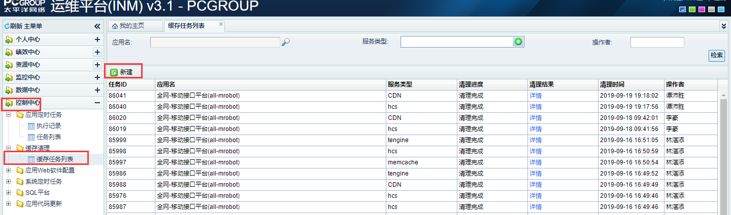
选all-mrobot，选hcs，选全选
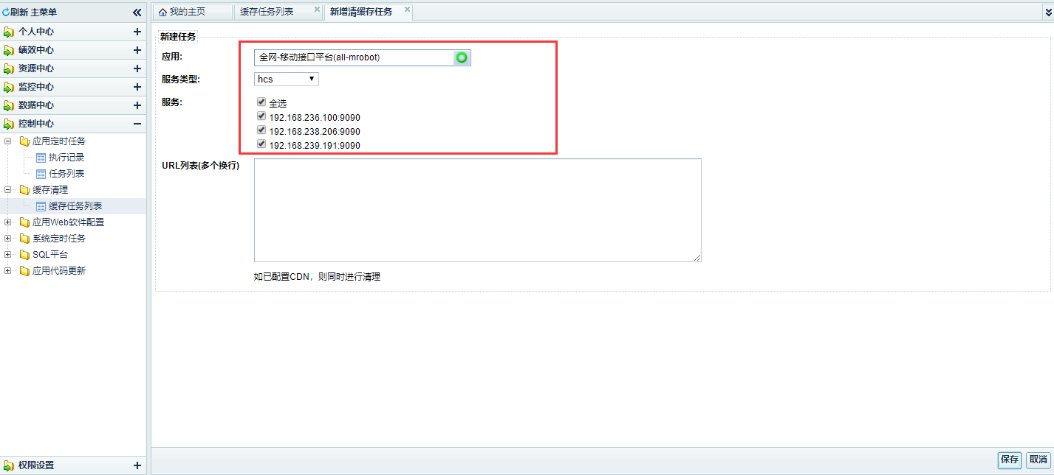
ios：
https://mrobot.pcauto.com.cn/xsp/s/auto/info/cms/getMrbtConfigs.xsp?keys=pcauto_browser_launch,pcauto_ad_close_config,pcauto_doc,pcauto_info_articles.json,pcauto_v13_cms_iphone_channel_tree,pcauto_browser_switchs,pcauto_guide_price_range,pcauto_help_feedback,rank_search_titles
安卓：
https://mrobot.pcauto.com.cn/xsp/s/auto/info/cms/getMrbtConfigs.xsp?keys=pcauto_v13_cms_android_channel_tree,pcauto_guide_price_range,pcauto_android_qdtdh,pcauto_browser_switchs

要把2个url路径里面的 /xsp 删掉，得出2个url：
https://mrobot.pcauto.com.cn/s/auto/info/cms/getMrbtConfigs.xsp?keys=pcauto_browser_launch,pcauto_ad_close_config,pcauto_doc,pcauto_info_articles.json,pcauto_v13_cms_iphone_channel_tree,pcauto_browser_switchs,pcauto_guide_price_range,pcauto_help_feedback,rank_search_titles
https://mrobot.pcauto.com.cn/s/auto/info/cms/getMrbtConfigs.xsp?keys=pcauto_v13_cms_android_channel_tree,pcauto_guide_price_range,pcauto_android_qdtdh,pcauto_browser_switchs

还要先清v3的接口：v3的接口，就是将第一个问号前面的内容替换为
https://mrobot.pcauto.com.cn/v3/cms/getMrbtConfigs?
即系：
ios：
https://mrobot.pcauto.com.cn/v3/cms/getMrbtConfigs?
keys=pcauto_browser_launch,pcauto_ad_close_config,pcauto_doc,pcauto_info_articles.json,pcauto_v13_cms_iphone_channel_tree,pcauto_browser_switchs,pcauto_guide_price_range,pcauto_help_feedback,rank_search_titles
安卓
https://mrobot.pcauto.com.cn/v3/cms/getMrbtConfigs?
keys=pcauto_v13_cms_android_channel_tree,pcauto_guide_price_range,pcauto_android_qdtdh,pcauto_browser_switchs
然后http也要清下。
也就是总共要清以下这些url，然后清hcs和cdn，清2次。
ios：
v3的
https://mrobot.pcauto.com.cn/v3/cms/getMrbtConfigs?
keys=pcauto_browser_launch,pcauto_ad_close_config,pcauto_doc,pcauto_info_articles.json,pcauto_v13_cms_iphone_channel_tree,pcauto_browser_switchs,pcauto_guide_price_range,pcauto_help_feedback,rank_search_titles
http://mrobot.pcauto.com.cn/v3/cms/getMrbtConfigs?
keys=pcauto_browser_launch,pcauto_ad_close_config,pcauto_doc,pcauto_info_articles.json,pcauto_v13_cms_iphone_channel_tree,pcauto_browser_switchs,pcauto_guide_price_range,pcauto_help_feedback,rank_search_titles
非v3的
https://mrobot.pcauto.com.cn/s/auto/info/cms/getMrbtConfigs.xsp?keys=pcauto_browser_launch,pcauto_ad_close_config,pcauto_doc,pcauto_info_articles.json,pcauto_v13_cms_iphone_channel_tree,pcauto_browser_switchs,pcauto_guide_price_range,pcauto_help_feedback,rank_search_titles
http://mrobot.pcauto.com.cn/s/auto/info/cms/getMrbtConfigs.xsp?keys=pcauto_browser_launch,pcauto_ad_close_config,pcauto_doc,pcauto_info_articles.json,pcauto_v13_cms_iphone_channel_tree,pcauto_browser_switchs,pcauto_guide_price_range,pcauto_help_feedback,rank_search_titles
安卓：
v3的
https://mrobot.pcauto.com.cn/v3/cms/getMrbtConfigs?
keys=pcauto_v13_cms_android_channel_tree,pcauto_guide_price_range,pcauto_android_qdtdh,pcauto_browser_switchs

http://mrobot.pcauto.com.cn/v3/cms/getMrbtConfigs?
keys=pcauto_v13_cms_android_channel_tree,pcauto_guide_price_range,pcauto_android_qdtdh,pcauto_browser_switchs
非v3的
https://mrobot.pcauto.com.cn/s/auto/info/cms/getMrbtConfigs.xsp?keys=pcauto_v13_cms_android_channel_tree,pcauto_guide_price_range,pcauto_android_qdtdh,pcauto_browser_switchs
http://mrobot.pcauto.com.cn/s/auto/info/cms/getMrbtConfigs.xsp?keys=pcauto_v13_cms_android_channel_tree,pcauto_guide_price_range,pcauto_android_qdtdh,pcauto_browser_switchs
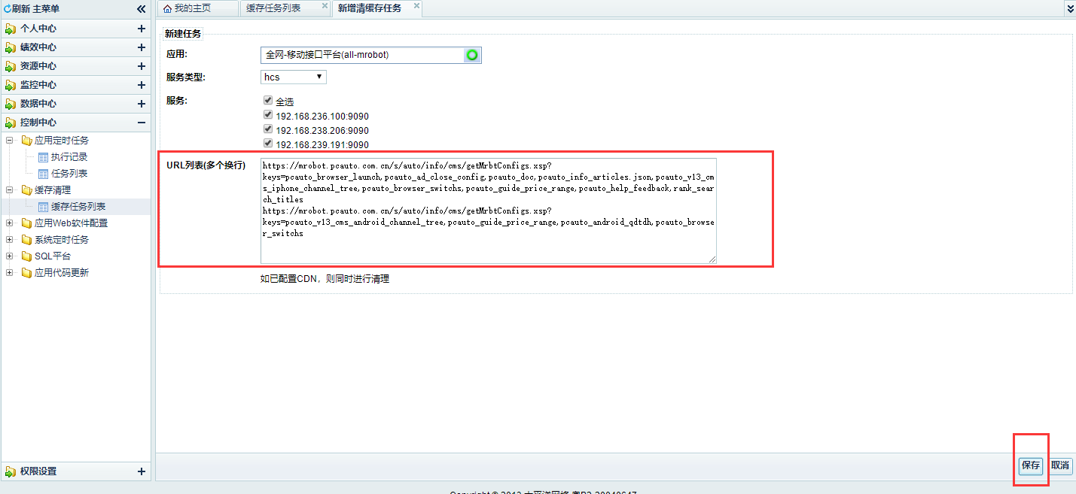
点击保存即可。

