论坛板块页整理
- Nginx跳转
- 外层nginx配置
location ~ ^/(topic|forum)-([\d]+).html {
include nginx_post.conf;
set $WEB_UPS "WEB_ATS";
if ( $cookie_gtats ~* "[0-9a-zA-Z]+" ) {
set $WEB_UPS "WEB_APP";
}
include nginx_spider.conf;
include nginx_waf.conf;
include nginx_req.conf;
proxy_pass http://$WEB_UPS;
proxy_redirect off;
proxy_set_header Host $host;
proxy_set_header X-Real-IP $remote_addr;
proxy_set_header X-Forwarded-For $proxy_add_x_forwarded_for;
add_header Cache-Control no-store;
}
location ~ ^/.*\.html {
include nginx_post.conf;
set $WEB_UPS "WEB_ATS";
if ( $cookie_gtats ~* "[0-9a-zA-Z]+" ) {
set $WEB_UPS "WEB_APP";
}
include nginx_spider.conf;
include nginx_waf.conf;
include nginx_req.conf;
proxy_pass http://$WEB_UPS;
proxy_redirect off;
proxy_set_header Host $host;
proxy_set_header X-Real-IP $remote_addr;
proxy_set_header X-Forwarded-For $proxy_add_x_forwarded_for;
}
- Nginx rewrite配置
(1) #forum
location ~ ^/forum-(.*).html {
rewrite ^/forum-([\d]+).html /forum.do?fid=$1 break;
#301
rewrite ^/forum-([\d]+)_replyat.html http://v71.pcauto.com.cn/forum-$1.html permanent;
rewrite ^/forum-([\d]+)_(\w+).html /forum.do?fid=$1&orderby=$2 break;
rewrite ^/forum-([\d]+)-((-|)[\d]+).html /forum.do?fid=$1&pageNo=$2 break;
#301
rewrite ^/forum-([\d]+)-((?:-|)[\d]+)_replyat.html http://v71.pcauto.com.cn/forum-$1-$2.html permanent;
rewrite ^/forum-([\d]+)-((?:-|)[\d]+)_(\w+).html /forum.do?fid=$1&pageNo=$2&orderby=$3 break;
}
链接：
1.http://bbs.pcauto.com.cn/forum-16488.html
2.http://bbs.pcauto.com.cn/forum-16488_replyat.html 301跳转到1
3.http://bbs.pcauto.com.cn/forum-16488_postat.html
4.http://bbs.pcauto.com.cn/forum-16488-2.html
5.http://bbs.pcauto.com.cn/forum-16488-2_replyat.html 301跳转到3
6.http://bbs.pcauto.com.cn/forum-16488-2_postat.html
(2) # type
location ~ ^/type_(.*).html {
rewrite ^/type_([^-]+)-([\d]+).html /forum.do?fid=$2&filter=type&fval=$1 break;
rewrite ^/type_([^-]+)-([\d]+)-((?:-|)[\d]+).html /forum.do?fid=$2&filter=type&fval=$1&pageNo=$3 break;
#301
rewrite ^/type_([^-]+)-([\d]+)_replyat.html http://v71.pcauto.com.cn/type_$1-$2.html permanent;
Rewrite ^/type_([^-]+)-([\d]+)_(\w+).html /forum.do?fid=$2&filter=type&fval=$1&orderby=$3 break;
#301
rewrite ^/type_([^-]+)-([\d]+)-((?:-|)[\d]+)_replyat.html http://v71.pcauto.com.cn/type_$1-$2-$3.html permanent;
rewrite ^/type_([^-]+)-([\d]+)-((?:-|)[\d]+)_(\w+).html /forum.do?fid=$2&filter=type&fval=$1&pageNo=$3&orderby=$4 break;
}
链接
1.http://bbs.pcauto.com.cn/type_g7efcg5408-16488.html#ad=10762
2.http://bbs.pcauto.com.cn/type_g7efcg5408-16488-3.html
3.http://bbs.pcauto.com.cn/type_g7efcg5408-16488_replyat.html#ad=10762 301跳转到1
4.http://bbs.pcauto.com.cn/type_g7efcg5408-16488_postat.html#ad=10762
5.http://bbs.pcauto.com.cn/type_g7efcg5408-16488-4_replyat.html 301跳转到2
6.http://bbs.pcauto.com.cn/type_g7efcg5408-16488-4_postat.html
(3) # Pick
location ~ ^/pick(.*).html {
rewrite ^/pick-([\d]+).html /forum.do?fid=$1&filter=pick break;
rewrite ^/pick-([\d]+)-((?:-|)[\d]+).html /forum.do?fid=$1&filter=pick&pageNo=$2 break;
#301
rewrite ^/pick-([\d]+)_replyat.html http://v71.pcauto.com.cn/pick-$1.html permanent;
rewrite ^/pick-([\d]+)_(\w+).html /forum.do?fid=$1&filter=pick&orderby=$2 break;
#301
rewrite ^/pick-([\d]+)-((?:-|)[\d]+)_replyat.html http://v71.pcauto.com.cn/pick-$1-$2.html permanent;
rewrite ^/pick-([\d]+)-((?:-|)[\d]+)_(\w+).html /forum.do?fid=$1&filter=pick&pageNo=$2&orderby=$3 break;
rewrite ^/pick_([^-]+)-([\d]+).html /forum.do?fid=$2&filter=pick&fval=$1 break;
rewrite ^/pick_([\d]+)-([\d]+)-((?:-|)[\d]+).html /forum.do?fid=$2&filter=pick&fval=$1&pageNo=$3 break;
#301
rewrite ^/pick_([\d]+)-([\d]+)_replyat.html http://v71.pcauto.com.cn/pick_$1-$2.html permanent;
rewrite ^/pick_([\d]+)-([\d]+)_(\w+).html /forum.do?fid=$2&filter=pick&fval=$1&orderby=$3 break;
#301
rewrite ^/pick_([\d]+)-([\d]+)-((?:-|)[\d]+)_replyat.html http://v71.pcauto.com.cn/pick_$1-$2-$3.html permanent;
rewrite ^/pick_([\d]+)-([\d]+)-((?:-|)[\d]+)_(\w+).html /forum.do?fid=$2&filter=pick&fval=$1&pageNo=$3&orderby=$4 break;
}
链接
1.http://bbs.pcauto.com.cn/pick-16488.html
2.http://bbs.pcauto.com.cn/pick-16488-3.html
3.http://bbs.pcauto.com.cn/pick-16488_replyat.html 301跳转到1
4.http://bbs.pcauto.com.cn/pick-16488_postat.html
5.http://bbs.pcauto.com.cn/pick-16488-3_replyat.html 301跳转到2
6.http://bbs.pcauto.com.cn/pick-16488-3_postat.html
7.http://bbs.pcauto.com.cn/pick_1-16488.html(精华帖分类)
8.http://bbs.pcauto.com.cn/pick_1-16488-3.html
9.http://bbs.pcauto.com.cn/pick_1-16488_replyat.html 301跳转到7
10.http://bbs.pcauto.com.cn/pick_1-16488_postat.html
11.http://bbs.pcauto.com.cn/pick_1-16488-3_replyat.html 301跳转到8
12.http://bbs.pcauto.com.cn/pick_1-16488-3_postat.html
用的比较少的链接，需确定是否已经没有入口：
- time(.*).html
- reward(.*).html
- voting(.*).html
- image(.*).html

- 豆腐块组成

<%@include file="forum_header.jspf"%>
forum_header.jspf中<%@include file="auto_common_header.jspf" %>
auto_common_header.jspf中<%@include file="static/header.html" %>（顶部导航）

- 轮播广告js控制

<%@include file="quick_nav.jspf"%>

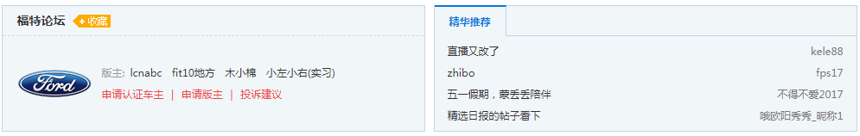
ssi引入：ssi/forum/loadAutoHeader.do?fid=${forum.fid}&forumType=${forumType}
缓存头缓存10分钟
先判断插件是否打开
pluginMap： SELECT * FROM bbs7_plugin WHERE NAME = 'picture_mode'
pluginMap.containsKey(auto_header)
//确定板块页是否还需要
获取版主和实习版主列表（左侧显示）
版主roleId=7，实习版主roleId=140
SELECT role.id, role.type, role.name, role.creditshigher,role.priority,
user_role.fid, user_role.uid,user_role.createat,user_role.createbyid
FROM bbs7_user_forum_role user_role, bbs7_role role WHERE user_role.roleid = role.id AND user_role.roleid = ? AND user_role.fid = ? order by createat asc
判断是否需要获取板块详情：SELECT * FROM bbs7_forumdetail WHERE fid = ?
判断是否需要获取产品库内容：从缓存和插件中获取
获取活动推荐select * from bbs7_activity where 1 = 1 and ( globalto > now() or recommendto > now() ) order by globalto desc
//确认下是否还有用
随机出4条该板块精华帖(右侧显示)：SELECT tid FROM bbs7_pick_new where 2>1 AND fid=? AND (pick+pick1+pick2+pick3+pick4+pick5)>0 order by pickat desc limit 0,15 Collections.shuffle打乱list，再取4条

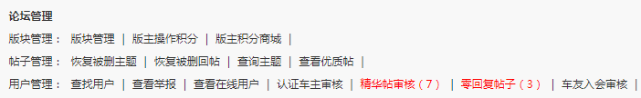
当前如果是登录状态，在页面js调接口判断论坛管理
获取当前用户的管理权限接口： http://bbs7.pcauto.com.cn/forum/loadDynamicInfos.ajax?fid={fid}&t={timestap}&c= {common_session_id}

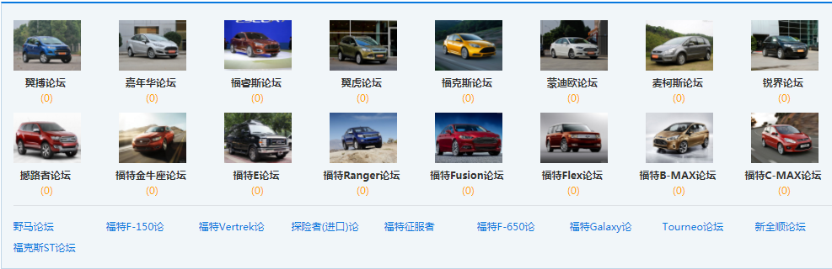
当前版块子版块
ssi引入：<!--#include virtual="ssi/forum/loadSubforums.do?fid=${forum.fid}"-->
缓存头设置30分钟缓存
先从缓存中取，没有再从数据库取
String key = FORUM_CHILD_KEY + forum.getFid();
SELECT fid FROM bbs7_forum WHERE parentId=? ORDER By seq
过滤掉隐藏版块

- 主体数据（帖子列表）放在后边

- 主体数据中的全站置顶帖
ssi引入ssi/forum/loadGlobalTops.do
缓存头设置1个小时缓存
先从缓存中查key = AllTopTopic
SELECT topid,tid,fid,createat,expireat,global,reason FROM bbs7_top WHERE fid=1 AND global=1 AND expireat > ? ORDER BY createat desc

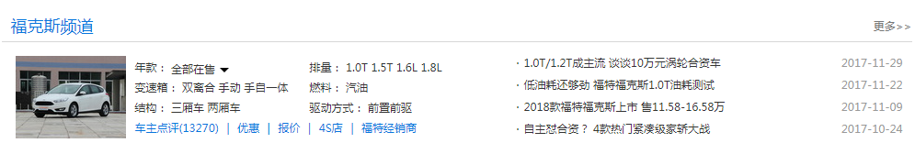
车系频道豆腐块
/ssi/forum/channel.do
缓存2个小时
(该版块有对应的车系id才调接口加载)
http://price.pcauto.com.cn/interface/bbs/serial_group_info.jsp?from=1&sid={serialId}
http://price.pcauto.com.cn/interface/bbs/serial_group_article.jsp?sid={serialId}

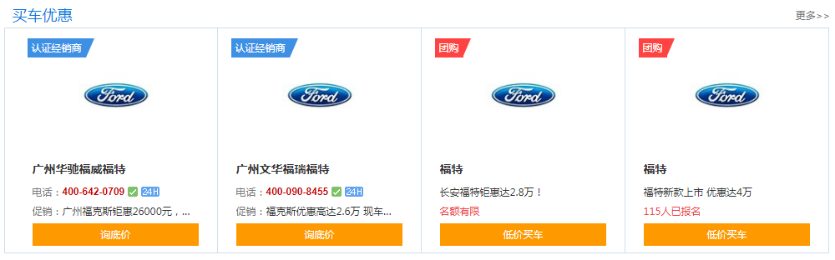
买车优惠豆腐块
经销商数据，团购数据，在页面js调接口加载
经销商：
http://price.pcauto.com.cn/dealer/interface/dealer_json.jsp?sid=3404&rid=1&max=2&callback=__doShowDealer
团购：
http://mall.pcauto.com.cn/autoMall/interface/outerInterface/list_super_activity_gct_importcar_json.jsp?showMax=2&serialGro upId=3404&regionId=1&callback=__showMallDataBlock


车问答和专栏豆腐块
ssi引入：ssi/forum/featureAndQuestionBlock.do
缓存头设置一周缓存
如果该版块有对应车系，调接口：http://ks.pcauto.com.cn/_pickax/s228?pieceBbsListJSON
车问答（分为虚拟子版块和非虚拟子版块）：
SELECT tid from bbs7_topic_13 WHERE type='question' AND fid=? AND subforumid=? ORDER BY createat DESC
SELECT tid from bbs7_topic_13 WHERE type='question' AND fid=? ORDER BY createat DESC

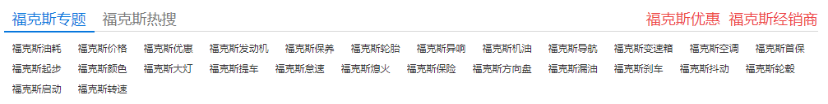
专题与热搜豆腐块
ssi引入ssi/forum/specialAndTagByUpdateAt.do
缓存头设置一周缓存
http://autosem.pc.com.cn/seo/special/getSerialSpecialData.do?num=26&serialId=228（先从缓存（24小时） 中取，如果没有再调接口）
http://autosem.pc.com.cn/bbs/web/listTagByHeat.do?serialId=228

学车论坛豆腐块
ssi引入学车论坛：ssi/forum/xczt.do

缓存头缓存一周
http://autosem.pc.com.cn/seo/xuecheSpecial/xuecheSpecialHotData.do?forumId=228

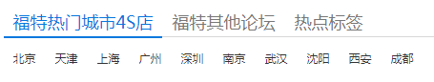
缓存头缓存一周
其他论坛：排除当前版块的子版块（5个）
SELECT fid FROM bbs7_forum WHERE parentId=? ORDER By seq
Auto4S插件打开：http://price.pcauto.com.cn/interface/bbs/bbs_auto_serial.jsp?bbsId=14637

- 页面调用其他接口
- 问答帖入口：http://bbs.pcauto.com.cn/wenda-14637.html
  - Nginx跳转
/bbs7/wenda-([\d]+).html /bbs7/question.do?fid=$1; break;
- 车友会入口：http://bbs.pcauto.com.cn/club-14637.html
  - Nginx跳转
/bbs7/club-([\d]+).html /bbs7/forum_club.do?fid=$1;
- 提问入口：http://bbs.pcauto.com.cn/new/post.do?fid=14637&type=question#ad=10763
- 发帖入口：
      - http://bbs.pcauto.com.cn/new/post.do?fid=14637#ad=10763
      - http://bbs.pcauto.com.cn/new/post.do?type=question&fid=14637#ad=10763
      - http://bbs.pcauto.com.cn/post.do?type=vote&fid=14637#ad=10763
- 其他接口：
- 判断是否收藏论坛接口：
http://v81.pcauto.com.cn/bbsapi/1.0/club/isBindUserForum.do?forumId={forumI d}&u serId={userId}
- 查看在线用户：
http://bbs.pcauto.com.cn/action/online_user.do
- 认证车主审核数量：http://v71.pcauto.com.cn/plugin/vip/getToBeCensorCount.do?fid=298
- 精华帖审核数量：http://v71.pcauto.com.cn/count4Censor.do?fid=298
- 零回复帖子数量：http://v71.pcauto.com.cn/count4NoReply.do?fid=298
- 版主推荐帖子数量：http://v71.pcauto.com.cn/countPickRecommend.do?fid=298
- 官方车友会活动审核数量： http://v71.pcauto.com.cn/topic/review/getModeratorUnReviewCount.do?fid=298
- 车友入会审核数量： http://v81.pcauto.com.cn/bbsappapi/gf/1.0/countApplys/get.do?uid=1254632
- 未解决问题数量：http://autosem.pc.com.cn/bbs/forum/count4PushAnswer.do?fid=298
- 系统消息： http://bip.pcauto.com.cn/intf/message.jsp?act=getNumToJson&siteId=2&status=0&callback=?
- 帖子查看数： http://v71.pcauto.com.cn/forum/loadStaticInfos.ajax?isBrandForum=true&tids=tid1,tid2&fid=2 98

- 主体数据
逻辑处理在forum.do接口
- 参数
fid,pageNo,pageSize,orderBy
特有参数：
fourm:
type:filter=type,fval
pick:fval
"pick".equals(filter) 常量PICK_PAGE_SIZE 25
其他读配置 先从appConfigMap，没有再从数据库中查，最大值200 SELECT * FROM `bbs7_app_config` WHERE appname = 'ForumPageSize'
- 判断版块是否存在SELECT * FROM bbs7_forum WHERE fid = 298，不存在跳404
- 验证是否有浏览管理版块(版主俱乐部,回收站版块)权限checkAdminForum
读配置，从appConfigMap中查找
SELECT * FROM `bbs7_app_config` WHERE appname = 'adminForumId' forumId:21245
SELECT * FROM `bbs7_app_config` WHERE appname = 'crashForumId' forumId:715
a.如果当前访问版块是管理版块，不设置缓存，进一步验证是否有权限actionValidate.validate
Action和validateMap bbs7_validate.xml
没有权限，获取当前用户组信息，先判断是否被锁了IP或游客，不是再获取用户角色
fid为1时，直接获取用户的最大管理角色
抛异常，体现在页面提示
b.如果当前访问版块不是管理版块，设置5分钟缓存
- redirecturl不为空跳转到redirecturl
- 判断是否是图片模式
初始化插件pluginMap
SELECT pluginid, NAME, description, url, STATUS FROM bbs7_plugin WHERE NAME = 'picture_mode'
查找picture_mode
value==1时，request.setAttribute("piclist", "image".equals(filter) ? 1 : 0);
- pageNo=1时，查版块置顶帖
先从缓存中找FORUM_TOP_CACHE_KEY + fid(5分钟缓存)
SELECT topid,tid,fid,createat,expireat,global,reason FROM bbs7_top WHERE global=0 AND fid=? AND expireat > ? ORDER BY createat desc
参数:当前访问版块id，当前日期
批量查帖子信息select * from bbs7_topic_13 where tid = ?
- 查版块帖子列表
pageNo == 1 && StringUtils.isEmpty(filter) && StringUtils.isEmpty(filterValue) && StringUtils.isEmpty(orderBy)获取第一页版块帖子topicService.getFirstPagerCache(forum, pageSize)
先从缓存中查
mc String key = "TopicPager-" + fid + "-" + pageSize;
缓存为空，从数据库中查
SELECT * FROM `bbs7_forum_index` WHERE fid = 298 查出帖子分表13
排序createat，lastpostat，默认lastpostat

- 非虚拟子版：(virtualforum = 1)：fid 298

版块帖子总数量 SELECT count(tid) FROM bbs7_topic_13 WHERE 1 < 2 AND fid = ? AND review = 1

帖子id:SELECT tid FROM bbs7_topic_13 WHERE 1 < 2 AND fid = ? AND review = 1 ORDER BY lastpostat DESC LIMIT 0,100
批量查帖子信息：SELECT * FROM bbs7_topic_13 WHERE tid = ?

2.虚拟子版(virtualforum = 1)：fid 297
参数：parentId,fid
版块帖子总数量SELECT count(tid) FROM bbs7_topic_11 WHERE 1 < 2 AND fid = ? AND subForumId = ? AND review = 1

帖子id SELECT tid FROM bbs7_topic_11 WHERE 1 < 2 AND fid = ? AND subForumId = ? AND review = 1 ORDER BY lastpostat DESC LIMIT 0,100

批量查帖子信息：SELECT * FROM bbs7_topic_13 WHERE tid = ?

其他情况，从数据库查

/forum-(.*).html
参数：fid,orderBy,pageNo,pageSize
1.虚拟子版：
查出帖子分表SELECT * FROM `bbs7_forum_index` WHERE fid = ？
版块帖子总数量SELECT count(tid) FROM bbs7_topic_分表index WHERE 1 < 2 AND fid = ? AND review = 1
帖子id集合：SELECT tid FROM bbs7_topic_分表index WHERE 1 < 2 AND fid = ? AND subForumId = ? AND review = 1 ORDER BY ? DESC LIMIT (pageNo-1)*pageSize,pageSize
批量查帖子信息：SELECT * FROM bbs7_topic_分表index WHERE tid = ?
2.非虚拟子版：
查出帖子分表SELECT * FROM `bbs7_forum_index` WHERE fid = ？
版块帖子总数量SELECT count(tid) FROM bbs7_topic_分表index WHERE 1 < 2 AND fid = ? AND review = 1
帖子id集合：SELECT tid FROM bbs7_topic_分表index WHERE 1 < 2 AND fid = ? AND review = 1 ORDER BY ? DESC LIMIT (pageNo-1)*pageSize,pageSize
批量查帖子信息：SELECT * FROM bbs7_topic_分表index WHERE tid = ?

/type-(.*).html
参数:fid,filter=type,fval,pageNo,pageSize,orderBy
filter参数获取查询的字段，如category，pick,favl获取字段的值
forum的categories属性进行主题分类：综合,新车作业,用车心得,改装美容,保养维护,油耗分享, 事故教训,自驾游记,腐败聚会,公告公示，在链接上显示编码为16进制后的字符串 综合 -->g7efcg5408
fval是16进制字符串，先解码成中文

也要分为虚拟子版和非虚拟子版

非虚拟子版：
查出帖子分表SELECT * FROM `bbs7_forum_index` WHERE fid = ？
帖子总数量SELECT count(tid) FROM bbs7_topic_13 WHERE 1 < 2 AND fid = ? AND category = ? AND review = 1
帖子id集合SELECT tid FROM bbs7_topic WHERE 1 < 2 AND fid = ? AND category = ? AND review = 1 ORDER BY orderBy DESC LIMIT (pageNo-1)*pageSize,pageSize
批量查询帖子信息SELECT * FROM bbs7_topic_分表index WHERE tid = ?

/pick-(.*).html
参数fid,filter=pick,fval,pageNo,orderby
fval：int类型精华分类，存在配置中
SELECT count(tid) FROM bbs7_topic_分表index WHERE 1 < 2 AND fid = ? AND pick > 0 AND pickClassify = ? AND review = 1
SELECT tid FROM bbs7_topic_分表index WHERE 1 < 2 AND fid = ? AND pick > 0 AND pickClassify = ? AND review = 1 ORDER BY lastpostat DESC LIMIT 0,25
虚拟子版：subForumId = {fid} AND fid = {parentId}
非虚拟子版：fid = {fid}
- 输入页码超过本身总页数时转跳默认首页

需要确定下是否不要这个逻辑了

pager.getPageCount()总页数，pager.getTotalPage()=0
if (pager.getPageSize() > 0 && pageNo > pager.getPageCount() && pager.getTotalPage() > 0) {
return "redirect:" + Functions.defaultHtmlUrl(request);
}
Pager的构造函数
public Pager() {}
public Pager(int pageNo, int pageSize, int totalSize) {
this.pageSize = pageSize;
this.totalSize = totalSize;
if (totalSize <= pageSize) {
this.pageNo = 1;
this.totalPage = 1;
} else {
this.pageNo = pageNo;
this.totalPage = totalSize / pageSize + (totalSize % pageSize == 0 ? 0 : 1);
}
}
public int getPageCount() {
return totalSize / pageSize + (totalSize % pageSize == 0 ? 0 : 1);
}

- 如果包含子版块，获取该版块的直接子版
String key = FORUM_CHILD_KEY + forum.getFid();
SELECT fid FROM bbs7_forum WHERE parentId=? ORDER By seq
过滤掉隐藏版块

- forumType
SELECT id, name, description FROM bbs7_forumgroup where id = forum.getGroupId()
sBrandForum forumType=iCar||forumType=niCar

- isThemeForum
fid = themeAutoClubMap.keySet()
SELECT * FROM `bbs7_app_config` WHERE appname = 'themeAutoClubUrl'

- 获取当前版块的对应车系
select * from plugin_auto_forum2serial

//判断当前版块类型
String forumType = forumGroupService.getForumType(fid);

public String getForumType(long fid) {
if(fid==0){
throw new BBS7Exception("不存在的版块");
}
Forum forum = forumDao.find(fid);
if(forum == null){
throw new BBS7Exception("不存在的版块");
}
ForumGroup group = findForumGroup(forum.getGroupId());

return group == null ? TYPE_OTHER : group.getName();
}

boolean isBrandForum = forumGroupService.isBrandForum(forumType);
public boolean isBrandForum(String type) {
return TYPE_IMPORTANT_CAR.equals(type) || TYPE_NOT_IMPORTANT_CAR.equals(type);
}
public String getForumType(long fid) {
if(fid==0){
throw new BBS7Exception("不存在的版块");
}
Forum forum = forumDao.find(fid);
if(forum == null){
throw new BBS7Exception("不存在的版块");
}
ForumGroup group = findForumGroup(forum.getGroupId());
return group == null ? TYPE_OTHER : group.getName();
}

